Prepositional Phrase Attribute

✅ What is Prepositional Phrase Attribute?
# Source: AI Source: Provided by: [Data Path: Persons Table -> ID Column: 1, Name_En Column: Motasem Essam] -> From: [Chatgpt (GPT‑5 Mini)] on [8/7/2025]
A Prepositional Phrase Attribute is a prepositional phrase that functions as an attribute by modifying a noun, giving additional information such as location, source, content, purpose, or association.
It typically functions like an adjective, answering “which one?” or “what kind?”

🔹 Structure:
# Source: AI Source: Provided by: [Data Path: Persons Table -> ID Column: 1, Name_En Column: Motasem Essam] -> From: [Chatgpt (GPT‑5 Mini)] on [8/7/2025]
Prepositional Phrase = preposition + noun phrase
Position: Usually follows the noun it modifies

🔹 Functions of Prepositional Phrase Attributes:
# Source: AI Source: Provided by: [Data Path: Persons Table -> ID Column: 1, Name_En Column: Motasem Essam] -> From: [Chatgpt (GPT‑5 Mini)] on [8/7/2025]
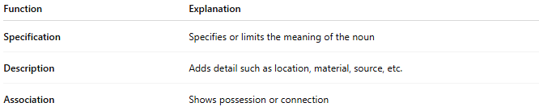
Function | Explanation
Specification | Specifies or limits the meaning of the noun
Description | Adds detail such as location, material, source, etc.
Association | Shows possession or connection

🔹 Examples in Sentences:
# Source: AI Source: Provided by: [Data Path: Persons Table -> ID Column: 1, Name_En Column: Motasem Essam] -> From: [Chatgpt (GPT‑5 Mini)] on [8/7/2025]
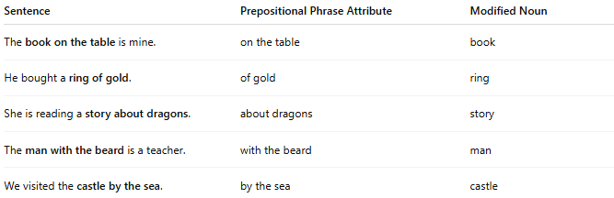
Sentence | Prepositional Phrase Attribute | Modified Noun
The book on the table is mine. | on the table | book
He bought a ring of gold. | of gold | ring
She is reading a story about dragons. | about dragons | story
The man with the beard is a teacher. | with the beard | man
We visited the castle by the sea. | by the sea | castle

🔹 Quick Summary Table:
# Source: AI Source: Provided by: [Data Path: Persons Table -> ID Column: 1, Name_En Column: Motasem Essam] -> From: [Chatgpt (GPT‑5 Mini)] on [8/7/2025]
Type | Acts Like | Position | Modifies
Prepositional Phrase Attribute | Adjective | After the noun | Noun

🔹 Common Prepositions in Attributes:
# Source: AI Source: Provided by: [Data Path: Persons Table -> ID Column: 1, Name_En Column: Motasem Essam] -> From: [Chatgpt (GPT‑5 Mini)] on [8/7/2025]
- of (a piece of cake)
- with (a girl with red hair)
- in (a book in the drawer)
- on (a hat on the shelf)
- about (a story about love)

